TNE20003 – Internet and Cybersecurity for Engineering Applications

Portfolio Task – Lab 4 Pass Task

Aims:
- To investigate how routing works and what routers do with broadcast packets.

Preparation:
  - View “Network Devices - Routers and Switches”

Due Date:
- Your Task will be assessed via an online quiz. You must score the required minimum to pass the test. You will be allowed a number of attempts to pass the test at the grade level you attempt. You are encouraged to complete the test at the end of the lab but if you do not, you must complete it before your next lab class.

Task 1.
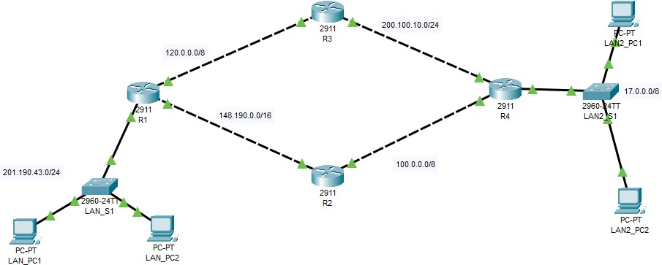
Build the network provided in figure 1 with Cisco Packet Tracer and observe the routing tables in each of the routers

Task 2.
Figure 1

Implement the network shown in figure 1 above.
If you need help creating the diagram refer to the instructions in labs 1 & 2.

Investigate the initial routing table entries in each of the routers

  - On R1 go to the CLI mode and press enter until you see R1>
  - At the R1> prompt type “enable” This will take you to the privileged mode where you can see the status of the router.
  - At the R1# prompt type “sh ip ro” this is short for show ip route.

  - Note what is displayed. You should see 3 C’s along with some network addresses. If you do not, seek help.
  - Repeat steps (a)-(d) above on the other 3 routers and note what you see.

Configure routing paths for complete end-to-end connectivity.

  - Next, we will configure a dynamic routing protocol (find out the purpose of a dynamic routing protocol if you are interested). Go back to R1 and at the R1# prompt type “conf t”, which is short for configure terminal.
  - Your prompt should now be R1#(config). To enter the mode where we configure the routing protocol type the command “router rip”.
  - Your prompt should now be R1#(config-router). Now we must advertise all networks that we want other routers to know about. Usually this is all connected networks. At the current prompt, type the following commands; “network 201.190.43.0”, “network 120.0.0.0” & “network 148.190.0.0”
  - At the R1#(config-router) prompt type “do sh ip ro”. Note that when you are in a sub-config mode, ie any config mode other than R1#(config) you will need to use the “do” before entering the command you want to use.
  - Now go to the other 3 routers and type the “sh ip ro” command at the R?# prompt. What do you see?
The only see the C and L address on other 3 router.
  - Why has the output not changed?
Because I have not config RIP on the other router(R2,R3,R4).

Now configure routing on all routers.
  - Next we will configure dynamic routing on R2 and at the R2# prompt type “conf t”.
  - Your prompt should now be R2#(config). To enter the mode where we configure the routing protocol type the command “router rip”.
  - Your prompt should now be R2#(config-router). Now we must advertise all networks that we want other routers to know about. Usually this is all connected networks. At the current prompt type the following commands; “network 100.0.0.0” & “network 148.190.0.0”
  - At the R2#(config-router) prompt, type “do sh ip ro”. Explain what do you see?
I see the 2 network address have been add.
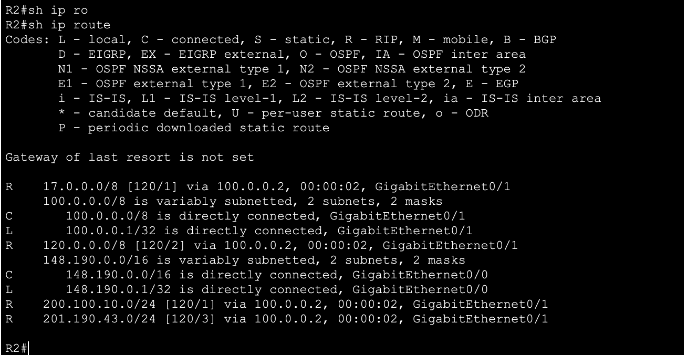
  - Go back to R1# and type “sh ip ro”. Explain what you see?
I see the 3 dynamic route network address have been add.
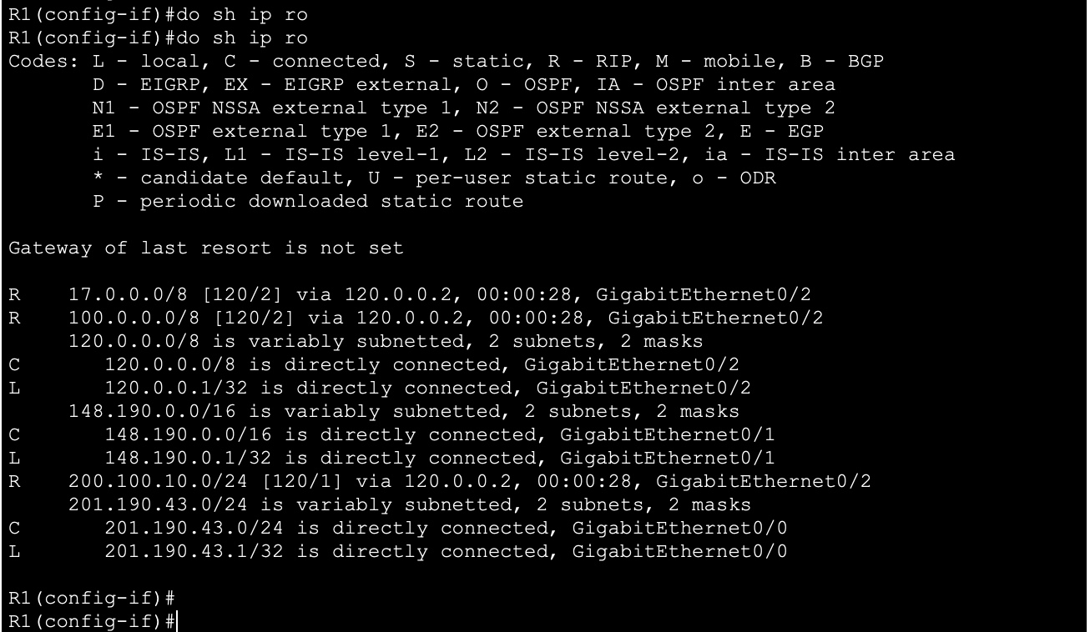
  - Go back to R3# and type “sh ip ro”. What do you see? Why don’t you see the new networks you saw in R1 & R2?
No, I don’t see it because I have not config it yet.
  - Repeat (a)-(f) and make sure that all routers are running RIP and advertising all of their connected networks like you did for R1 & R2.

Trace the data path from a PC.

  - Click on the LAN_PC1 and choose “desktop” and then click on the “command prompt”
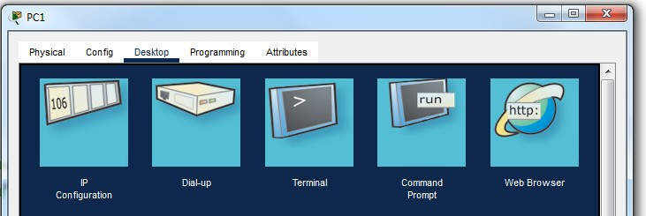

  - In the “command prompt” window type “tracert (ip address of LAN2_PC1)”. Conversely you may use the simulator and the envelopes like you did in lab 1. Do this 3 times. The outputs should vary.
  - Note what is displayed. Which way did the traffic go? Can you explain why?
The traffic go from R1 to R3 , then to R4 then to PC1 Lan 2.
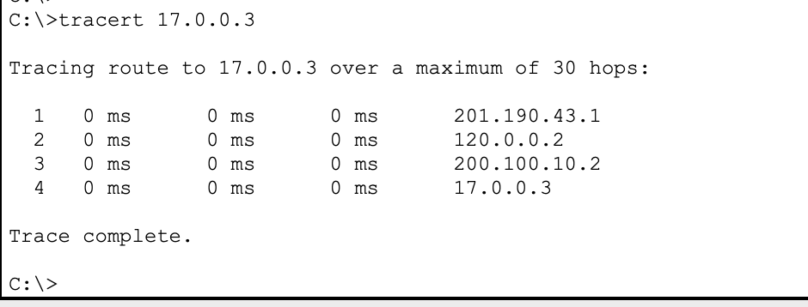

Investigate path choice in routers.

  - Add another router R5 between R3 and R4. Keep the network address of 200.100.10.0/24 between R3 and R5 and then use the network of 200.50.50.0/24 between R5 and R4. Remember to change the R4 interface address that belonged to the 200.100.10.0/24 network from before. Remember to enable RIP on the new router R5 with the networks that are connected to it.
  - Now repeat step 5 above and click on the LAN_PC1 and choose “desktop” and then click on the “command prompt”

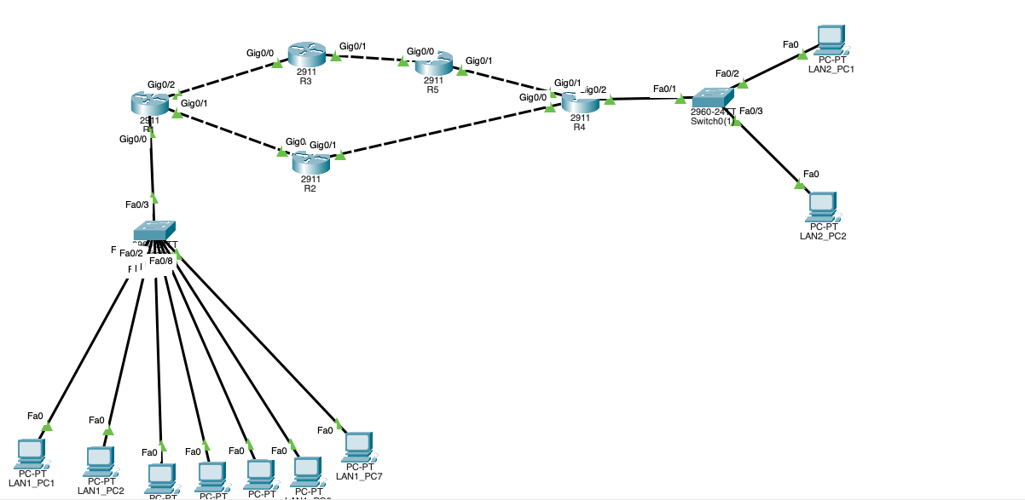

  - In the “command prompt” window type “tracert (ip address of LAN2_PC1)”. Conversely you may use the simulator and the envelopes like you did in lab 1. Do this 3 times.
  - Note what is displayed. Which way did the traffic go? Can you explain why?
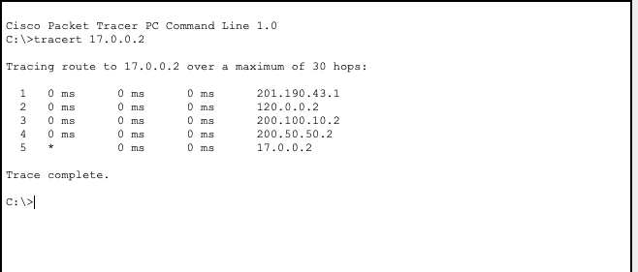
The packet is forward form Router 1 to Router 3 to Router 5 to Router 4 and go to LAN2_PC1.
  - On R1 find which of your GigabitEthernet interfaces connects R1 to R2. Then check the “ON” box so that it is not selected or is off. This action turns the interface off, meaning that it will stop forwarding traffic out of this interface. See the pic below:
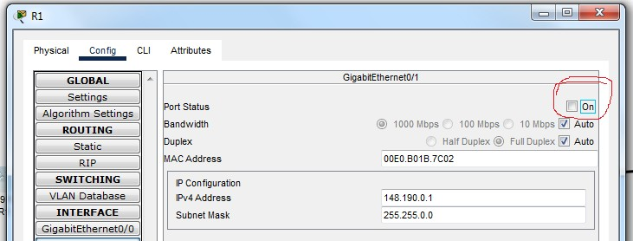

Verify that routers block broadcasts.

  - As in lab 1, click simulation and then under edit filters only enable/tick IPv4 and under that tab the ARP and ICMP protocols as in the pic below
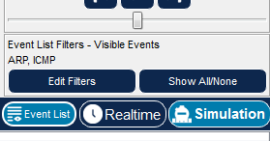

  - Add another 5 PCs to your design space and connect them to LS1. Label them as you want. You do not need to give them IP addresses as LS1 will work only at L2.
  - Verify that both LAN_PC1 & LAN_PC2 have empty ARP tables. If they don’t, enter the command arp –d in the command prompt for either or both PCs. Also verify that LS1 has an empty CAM table, if not enter the command “clear MAC address-table”. You know that ARP is a broadcast process, requesting to find the MAC address that matches the user-entered IP address.
  - Click on the envelope and then click on LAN_PC1 as the source and the LAN2_PC2 as the destination.
  - Run the simulation. What do you observe? Comment on what happens to the first packet/envelope and then the second packet/envelope
The first packet was sent to the switch and then the packet spread to all PC which connect to the LS1. The second packet was transfer to the R1 then.
  - Did the router pass on the first packet/envelope? Explain why or why not.
No, it did not. The R1 pass the first packet back to the PC to determine the path where the packet should be sent.

~~~~~ End of Lab ~~~~~

